It is the Homeowner’s responsibility to obtain any government issued permits that may be required for the proposed alteration and to have any underground utilities identified to prevent damages from occurring. Please allow at least 14 business days for the Bayview Estates (BVE) Community Board to review this application for compliance with the Community’s relevant Rules & Regulations and Declarations. Requests for approval are required when work is completed that changes or adds to the exterior of a lot, no approval is needed to restore, replace, or clean the exterior of a lot with no alternation to its appearance (refer to the Rules & Regulations/Declarations or email the board for guidance on what constitutes a material change). Please submit this application, along with supporting documentation, status updates, and questions to Bayviewestateshoaboard@gmail.com.
Applicant(s)
Homeowner (1)
Homeowner (2)
Number & Street
Phone (text alright?)
Email (primary)
Email (secondary)
Describe proposed alteration, attach additional sheets if necessary__Window and siding replacement
_____________________________________________________________________________
Contractor’s Name (if applicable):____________________________
Date work is to begin:________ Estimated Completion date:________
Signature of Homeowner:__________________Date:_________
Signature of Co-Homeowner:______________________________Date:_________________
Printed name of Homeowner(s)_______________________________________________

Please include the following supporting documentation:
- ______Total dimensions of proposed project, if applicable, include square footage
- ______ A copy of the contractor's work license and certificate of insurance.
- ______Complete list of materials to be used (including manufacturer, sample from the Williamsburg Color Wheel, and model number)
- ______Plat showing property boundaries with the area of the proposed alteration drawn on it
- ___Attached Photos show color of siding, trim, and shutters___Illustration of the proposed project, (a working web-link may be used)
_____ / _____ The Homeowner(s) hereby agree that any and all liability caused by, or arising from, this modification shall be assumed by the Homeowner(s). Homeowner(s) agree to release Bayview Estates, its board, and agents of any and all liability.
_____ / _____ The homeowner(s) agree to abide by all decisions of the BVE Community Board, whose approval is for the outward appearance only and does not imply any engineering review of a structural nature has been completed. Any construction pursuant to the provisions of this approval shall be subject to the continuing effect of the provisions of the BVE governing documents (Declarations, Bylaws, Rules and Regulations of the Association) and the BVE Community Board. Any violation of the governing documents may incur penalties as permitted under those documents.
_____ / _____ No work will be done that is not included in this application without prior authorization from the Board. He/She will keep the Board up to date on any changes made to the project after work is commenced. No structure may be permanently installed in any drainage or utility easements.
Please direct any questions about this document to the President of the Community via email at Bayviewestateshoaboard@gmail.com.

Office Use Only Version 7/2025

Date Received:____________________________ by Email US Mail (Circle 1)

Board Decision: Approved Denied Date of Board Decision:_______________________

Date Applicant Informed:_________________________ Board follow-up required? YES NO

Date of Final Inspection:____________________ Inspected by:____________________
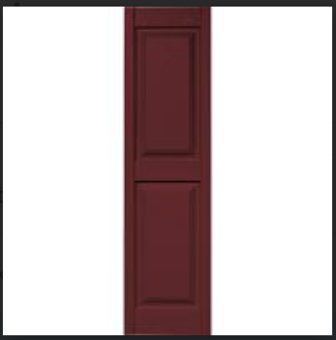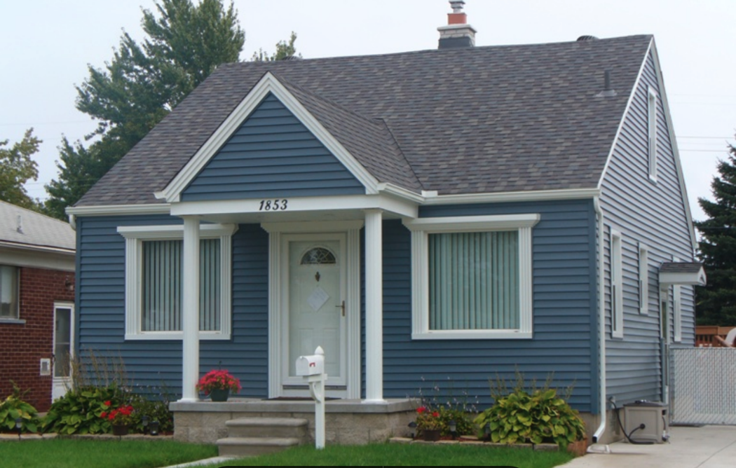

All Homeowners listed on the Deed must initial and sign this form where indicated.

